DIGITAL SYSTEM DESIGN LABORATORY
REPORT LAB 3

IMPLEMENTATION OF ADDERS, SUBTRACTORS, AND MULTIPLIERS USING VERILOG HDL

NAME: Bùi Gia Bảo

ID: ITITIU22019

I. PURPOSE OF THE EXPERIMENT
The purpose of this laboratory exercise is to examine arithmetic circuits that add, subtract, and multiply numbers. Each type of circuit shall be implemented in two ways: first by writing Verilog code that describes the required functionality, and second by making use of predefined subcircuits from Altera’s library of parameterized modules. The results produced for various implementations will be compared, both in terms of the circuit structure and its speed of operation. All circuits must be implemented using pure Verilog structural modeling with primitive gates, full adders, and hierarchical instantiation.

II. THEORETICAL BACKGROUND

II.1 Ripple-Carry Adder (RCA)
A ripple-carry adder is a combinational circuit that performs binary addition by cascading full adders (FAs). For an 8-bit adder:
$$S_{i}=A_{i}⊕B_{i}⊕C_{i},C_{i+1}=(A_{i}⋅B_{i})+(A_{i}⋅C_{i})+(B_{i}⋅C_{i})$$
- Carry propagation delay: The carry signal "ripples" from the least significant bit (LSB) to the most significant bit (MSB).
- Critical path: $C_{0}→C_{8}$through 8 full adders.
- Maximum delay: $T_{\text{total}}=T_{\text{XOR}}+8×T_{\text{FA}}$
- Advantage: Simple, regular structure, easy to model structurally.
- Disadvantage: Poor scalability due to $O(n)$delay.

II.2 Two’s Complement Representation and Overflow
In 8-bit two’s complement:
- Range: $[-128,+127]$
- Sign bit: $A_{7}$(0 = positive, 1 = negative)
Overflow occurs when the result of an addition exceeds the representable range:
- Two positive numbers → negative result
- Two negative numbers → positive result
Overflow detection logic: $\text{Overflow}=(A_{7}⋅B_{7}⋅¬S_{7})+(¬A_{7}⋅¬B_{7}⋅S_{7})$
This is implemented using AND, NOT, and OR gates.

II.3 Subtraction Using Two’s Complement
Subtraction $A-B$is implemented as: $A-B=A+(¬B+1)$
- Conditional inversion: $B⊕\{\text{sub},…,\text{sub}\}$
- Carry-in = sub signal
- Unified add/sub circuit controlled by a single bit.

II.4 Binary Multiplication and Array Multiplier
Binary multiplication follows the shift-and-add algorithm:
$$P=A×B=\sum_{i=0}^{7}{}(A×b_{i})≪i$$
- Partial products (PPs): Generated using AND gates: $pp_{i}[j]=a_{j}⋅b_{i}$
- Summation: Performed using full adders in a 2D array
- Array multiplier structure:
  - Regular, scalable, synthesizable
  - Critical path grows diagonally → $O(n)$delay per dimension

II.5 Registered Datapath and Pipelining
- Input registers: Sample inputs on clock edge → eliminate setup/hold violations
- Output registers: Stabilize outputs → improve observability
- Write Enable (WE): Controls register loading
- Pipelining: Inserting registers between combinational stages reduces critical path delay, increasing fmax

III. EXPERIMENTAL PROCEDURE

PART I: 8-BIT REGISTERED RIPPLE-CARRY ADDER WITH OVERFLOW

Objective
Design an 8-bit ripple-carry adder with registered inputs and outputs, and overflow detection (carry out) using structural Verilog.
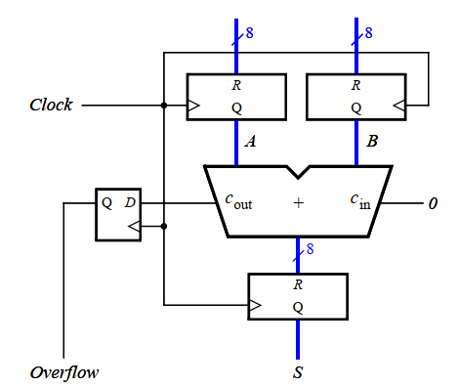
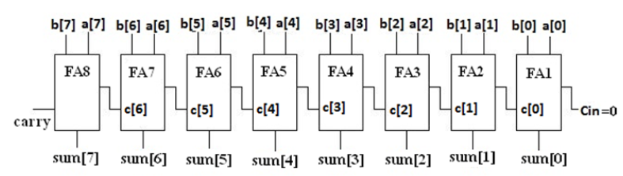

Step-by-Step Design

1. Gate-Level Full Adder
module full_adder (
input wire a, b, cin,
output wire sum, cout
);
wire p, g, c1;

// Propagate and Generate
xor (p, a, b);
and (g, a, b);

// Sum
xor (sum, p, cin);

// Carry-out
and (c1, p, cin);
or (cout, g, c1);
endmodule
Explanation:
- p = carry propagate
- g = carry generate
- Structural instantiation of primitive gates ensures no LPM usage

2. 8-Bit Ripple-Carry Adder (Structural)
module eight_bit_adder_stru (
input [7:0] a, b,
input cin,
output [7:0] sum,
output cout
);
wire [7:1] carry;

full_adder fa0 (a[0], b[0], cin, sum[0], carry[1]);
full_adder fa1 (a[1], b[1], carry[1], sum[1], carry[2]);
full_adder fa2 (a[2], b[2], carry[2], sum[2], carry[3]);
full_adder fa3 (a[3], b[3], carry[3], sum[3], carry[4]);
full_adder fa4 (a[4], b[4], carry[4], sum[4], carry[5]);
full_adder fa5 (a[5], b[5], carry[5], sum[5], carry[6]);
full_adder fa6 (a[6], b[6], carry[6], sum[6], carry[7]);
full_adder fa7 (a[7], b[7], carry[7], sum[7], cout);
endmodule

3. Top-Level Module (DE2-115)
module lab6_part1 (
input [17:0] SW,
input [1:0] KEY,
output [7:0] LEDR,
output [8:0] LEDG,
output [6:0] HEX7, HEX6, HEX5, HEX4, HEX1, HEX0
);
wire clk = KEY[1], reset_n = KEY[0];
wire [7:0] A_reg, B_reg, S_reg;
wire cout, overflow;

// Input Registers
dff8 regA (.d(SW[15:8]), .clk(clk), .clrn(reset_n), .q(A_reg));
dff8 regB (.d(SW[7:0]), .clk(clk), .clrn(reset_n), .q(B_reg));

// 8-bit Adder
eight_bit_adder_stru adder (.a(A_reg), .b(B_reg), .cin(1'b0), .sum(S_reg), .cout(cout));

// Output Register
dff8 regS (.d(S_reg), .clk(clk), .clrn(reset_n), .q(LEDR[7:0]));

// Overflow Detection
assign overflow = (A_reg[7] & B_reg[7] & ~S_reg[7]) | (~A_reg[7] & ~B_reg[7] & S_reg[7]);
assign LEDG[8] = overflow;

// 7-Segment Displays
hex7seg h7(SW[15:12], HEX7); hex7seg h6(SW[11:8], HEX6);
hex7seg h5(SW[7:4], HEX5); hex7seg h4(SW[3:0], HEX4);
hex7seg h1(LEDR[7:4], HEX1); hex7seg h0(LEDR[3:0], HEX0);
endmodule

Tasks
- Create Quartus Prime project and write the above Verilog code.
- Assign pins:
  - SW[15:8] → A, SW[7:0] → B
  - KEY[1] → Clock, KEY[0] → Reset
  - LEDR[7:0] → Sum, LEDG[8] → Overflow
- Compile and simulate using ModelSim. Verify overflow cases.
- Download to DE2-115 and test with switches.
- Open Timing Analyzer → Report:
  - fmax
  - Longest path delay
  - Logic Elements (LEs)

PART II: 8-BIT REGISTERED ADDER/SUBTRACTOR

Objective
Modify Part I to support addition and subtraction using a control signal SUB .
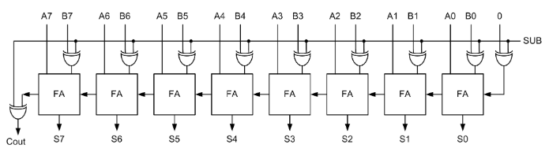

Theory Recap
- $A-B=A+(¬B+1)$
- Use XOR to conditionally invert B
- Carry-in = sub

Structural Add/Sub Module
module eight_bit_addsub_stru (
input [7:0] a, b,
input sub,
output [7:0] sum,
output cout, overflow
);
wire [7:0] b_comp;
wire [7:1] carry;

assign b_comp = b ^ {8{sub}}; // Invert B if sub=1

full_adder fa0 (a[0], b_comp[0], sub, sum[0], carry[1]);
full_adder fa1 (a[1], b_comp[1], carry[1], sum[1], carry[2]);
full_adder fa2 (a[2], b_comp[2], carry[2], sum[2], carry[3]);
full_adder fa3 (a[3], b_comp[3], carry[3], sum[3], carry[4]);
full_adder fa4 (a[4], b_comp[4], carry[4], sum[4], carry[5]);
full_adder fa5 (a[5], b_comp[5], carry[5], sum[5], carry[6]);
full_adder fa6 (a[6], b_comp[6], carry[6], sum[6], carry[7]);
full_adder fa7 (a[7], b_comp[7], carry[7], sum[7], cout);

assign overflow = (a[7] & b_comp[7] & ~sum[7]) | (~a[7] & ~b_comp[7] & sum[7]);
endmodule

Top-Level Module
module lab6_part2 (
input [17:0] SW,
input [1:0] KEY,
output [7:0] LEDR,
output [8:0] LEDG,
output [6:0] HEX7, HEX6, HEX5, HEX4, HEX1, HEX0
);
wire clk = KEY[1], reset_n = KEY[0], sub = SW[16];
wire [7:0] A_reg, B_reg, S_reg;
wire cout, overflow;

dff8 regA (.d(SW[15:8]), .clk(clk), .clrn(reset_n), .q(A_reg));
dff8 regB (.d(SW[7:0]), .clk(clk), .clrn(reset_n), .q(B_reg));

eight_bit_addsub_stru addsub (.a(A_reg), .b(B_reg), .sub(sub), .sum(S_reg), .cout(cout), .overflow(overflow));

dff8 regS (.d(S_reg), .clk(clk), .clrn(reset_n), .q(LEDR[7:0]));
assign LEDG[8] = overflow;

// 7-segment displays
hex7seg h7(SW[15:12], HEX7); hex7seg h6(SW[11:8], HEX6);
hex7seg h5(SW[7:4], HEX5); hex7seg h4(SW[3:0], HEX4);
hex7seg h1(LEDR[7:4], HEX1); hex7seg h0(LEDR[3:0], HEX0);
endmodule

Tasks
- Simulate add and subtract modes.
- Download to FPGA.
- Compare fmax and longest path with Part I.

PART III: 4-BIT ARRAY MULTIPLIER

Objective
Implement a 4×4 array multiplier using AND gates and full adders.
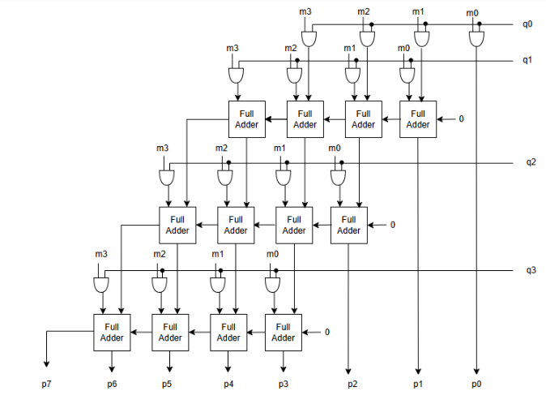

module array_multiplier_4x4 (
input [3:0] a, b,
output [7:0] p
);
wire [3:0] pp0, pp1, pp2, pp3;
wire [6:0] c;

assign pp0 = a & {4{b[0]}};
assign pp1 = a & {4{b[1]}};
assign pp2 = a & {4{b[2]}};
assign pp3 = a & {4{b[3]}};

assign p[0] = pp0[0];
full_adder fa00 (pp0[1], pp1[0], 1'b0, p[1], c[0]);

full_adder fa10 (pp0[2], pp1[1], c[0], p[2], c[1]);
full_adder fa11 (pp0[3], pp1[2], c[1], p[3], c[2]);
full_adder fa12 (pp1[3], 1'b0, c[2], p[4], c[3]);

full_adder fa20 (pp2[1], c[3], 1'b0, p[5], c[4]);
full_adder fa21 (pp2[2], c[4], 1'b0, p[6], c[5]);
full_adder fa22 (pp2[3], c[5], 1'b0, p[7], c[6]);

assign p[7] = pp3[3] ^ c[6];
endmodule

Top-Level 4-Bit Multiplier
module lab6_part3 (
input [11:0] SW,
output [6:0] HEX6, HEX4, HEX1, HEX0
);
wire [7:0] p;

array_multiplier_4x4 mult (.a(SW[11:8]), .b(SW[3:0]), .p(p));

hex7seg h6(SW[11:8], HEX6); hex7seg h4(SW[3:0], HEX4);
hex7seg h1(p[7:4], HEX1); hex7seg h0(p[3:0], HEX0);
endmodule

Tasks
- Simulate and verify with testbench.
- Display $A$, $B$, $P$on 7-segment displays.
- Test on DE2-115.

PART IV: 8-BIT REGISTERED ARRAY MULTIPLIER

Objective
Extend the 4-bit multiplier to 8×8 → 16-bit with input/output registers.
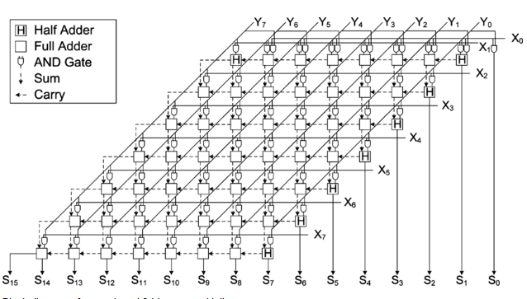

8×8 Array Multiplier (Hierarchical)
module array_multiplier_8x8 (
input [7:0] a, b,
input clk, clrn,
output [15:0] p
);
wire [7:0] A_reg, B_reg;
wire [15:0] p_comb;

dff8 regA (.d(a), .clk(clk), .clrn(clrn), .q(A_reg));
dff8 regB (.d(b), .clk(clk), .clrn(clrn), .q(B_reg));

// Full 8x8 array (use generate or hierarchical 4x4 blocks)
// ... (complex — implement using generate loops)

dff16 regP (.d(p_comb), .clk(clk), .clrn(clrn), .q(p));
endmodule

PART V: S = (A×B) + (C×D) WITH WRITE ENABLE

Objective
Implement a registered MAC unit with write enable and input selection.

Top-Level MAC Unit
module lab6_part5 (
input [17:0] SW,
input [1:0] KEY,
output [8:0] LEDG,
output [6:0] HEX7, HEX6, HEX5, HEX4, HEX3, HEX2, HEX1, HEX0
);
wire clk = KEY[1], clrn = KEY[0], we = SW[17], sel = SW[16];
wire [7:0] A, B, C, D, inA, inB;
wire [15:0] P1, P2, Sum;
wire cout;

assign inA = sel ? SW[15:8] : SW[15:8];
assign inB = sel ? SW[7:0] : SW[7:0];

dff8_we regA (.d(inA), .clk(clk), .we(we), .clrn(clrn), .q(A));
dff8_we regB (.d(inB), .clk(clk), .we(we), .clrn(clrn), .q(B));
// Repeat for C, D

array_multiplier_8x8 mult1 (.a(A), .b(B), .clk(clk), .clrn(clrn), .p(P1));
array_multiplier_8x8 mult2 (.a(C), .b(D), .clk(clk), .clrn(clrn), .p(P2));

eight_bit_addsub_stru adder16 (.a(P1), .b(P2), .sub(1'b0), .sum(Sum), .cout(cout));

dff16 regSum (.d(Sum), .clk(clk), .clrn(clrn), .q({HEX3,HEX2,HEX1,HEX0}));
assign LEDG[8] = cout;
endmodule

Your code here

……….

……….

IV. SUPPORT MODULES
module dff8(input [7:0] d, input clk, clrn, output reg [7:0] q);
always @(posedge clk or negedge clrn)
if (!clrn) q <= 0; else q <= d;
endmodule

module dff8_we(input [7:0] d, input clk, we, clrn, output reg [7:0] q);
always @(posedge clk or negedge clrn)
if (!clrn) q <= 0; else if (we) q <= d;
endmodule

module dff16(input [15:0] d, input clk, clrn, output reg [15:0] q);
always @(posedge clk or negedge clrn)
if (!clrn) q <= 0; else q <= d;
endmodule

module hex7seg(input [3:0] hex, output reg [6:0] seg);
always @(*) case(hex)
0: seg = 7'b1000000; 1: seg = 7'b1111001;
2: seg = 7'b0100100; 3: seg = 7'b0110000;
4: seg = 7'b0011001; 5: seg = 7'b0010010;
6: seg = 7'b0000010; 7: seg = 7'b1111000;
8: seg = 7'b0000000; 9: seg = 7'b0010000;
10: seg = 7'b0001000; 11: seg = 7'b0000011;
12: seg = 7'b1000110; 13: seg = 7'b0100001;
14: seg = 7'b0000110; 15: seg = 7'b0001110;
endcase
endmodule

